(A) REQUEST DETAILS

Schenker Request No: |  | Request Date: | 27 May 09
Request By: | Tay Jyh Huey | Client Name: | Apple
Priority  (E/H/M/L): | H | Application: | MVT HubApplication
Expected Date of Completion:
Request Title: | AppleCare SMART Project
Nature of Request (please tick):
Errors |  | New |  | Modifications |  | Others (please specify)

REQUEST DESCRIPTION
Country affected: Singapore

Scope
SMART project will be launched in Aug 09, we need to enhance the product label screen to allow user to manual input the following datas: - serial number, COO, Model.

Detail Specs

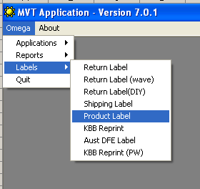

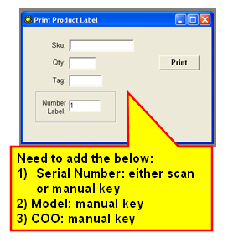
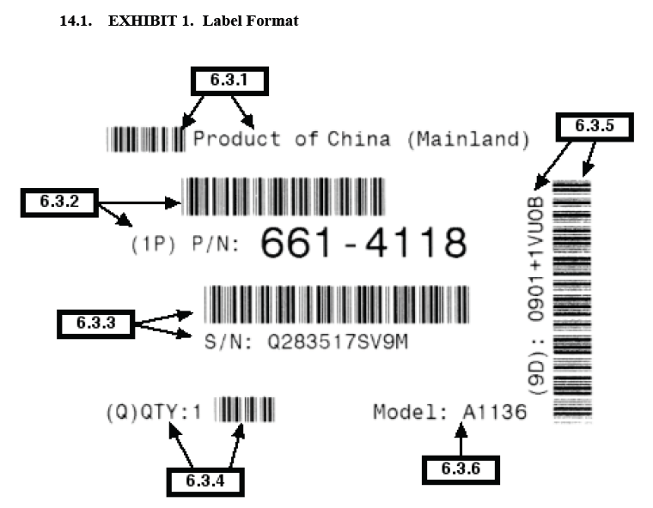

Authorized By: |  | Authorized Date:

(B) EVALUATION OF REQUEST
Comment:
(Proceed/Reject)
Assigned To: |  | Date Assigned:
Est.Effort (man day): |  | Estimated Cost:
Est Completion date:

Timeline/ Cost Approval
Approved By: |  | Date Approved:

Acceptance of Timeline and Cost
Accepted By: |  | Date Accepted:

( C ) PROGRAMS INSTALLATION DETAILS
Update User Document (Y/N):
Scheduled installation date/time
Installation to be performed by
Copy source codes to repository date
(D) TEST RESULT OF REQUEST
System Tested By: |  |  | Date:
User Sign-off By: |  |  | Date:
Sign-off Remarks:

Section A
Authorisation List:
Schenker Program Managers
Oh Wee Nee (SG), Amanda Yim (HK), Steve Hung (TW), Annie Zhou (CN), Johnny Zhou (AU), TS Yang (KR), Masahiro Ichikawa (TY)
Apple Program Managers
Ashwani Dang, Jennifer Yau
Project Managers (Project specific)
Project dependent

Section B
Evaluation of Request
Regional Business Owner
Eric Leong (Freight), Stuart Culverwell (Logistic)
Regional IT Acc Mgr
Budi Djojo

Approval of Cost/Timeline
Regional IT Director
Patrick Foong

Acceptance of Cost/Timelime
Regional Business Owner, Schenker Program Manager

Notes:
- Work will not start until authorized by is signed by head of dept (HOD) is completed.
- User sign-off indicates that the user has satisfied the request.

